Superstore Sales Dashboard (Tableau)

1. Project Title
Superstore Sales Performance Dashboard
Link — https://public.tableau.com/views/SalesAnalysisbyMonthRegionCategory/Dashboard1?:language=en-US&publish=yes&:sid=&:redirect=auth&:display_count=n&:origin=viz_share_link

2. Objective
The objective of this project was to design an interactive dashboard in Tableau that provides insights into sales performance across time, region, and product categories.
The dashboard enables business users to quickly analyze trends, compare regional performance, and understand category contributions to total sales.

3. Dataset
- Source: Superstore_Sales_Clean.csv (derived from Sample Superstore dataset)
- Columns used:
  - Order Date
  - Region
  - Category
  - Sales
  - Profit

4. Tools & Methods
- Tool Used: Tableau Desktop
- Data Preparation: Cleaned dataset with python
- Transformations:
  - Converted Order Date to Month-Year format
  - Aggregated Sales at month, region, and category levels
  - Created calculated field for % of Total Sales in category analysis

5. Visualizations
- Line Chart – Sales over Months
  - Shows monthly sales trends
  - Highlights seasonality and growth patterns
- Bar Chart – Sales by Region
  - Compares regional performance
  - Identifies best- and worst-performing regions
- Pie Chart – Sales by Category (replacing donut chart)
  - Shows contribution of each category (Furniture, Office Supplies, Technology)
  - Displays both value and % share of sales
- Filters / Slicers
  - Region filter to dynamically update all charts
  - Category filter for targeted insights

6. Dashboard Design
- Title: “Superstore Sales Performance Dashboard”
- Layout: Grid-based with line chart on top, region bar chart on left, category pie chart on right
- Colors: Highlighted top-performing categories/regions with distinct colors
- Interactivity: Global filters applied across all visualizations

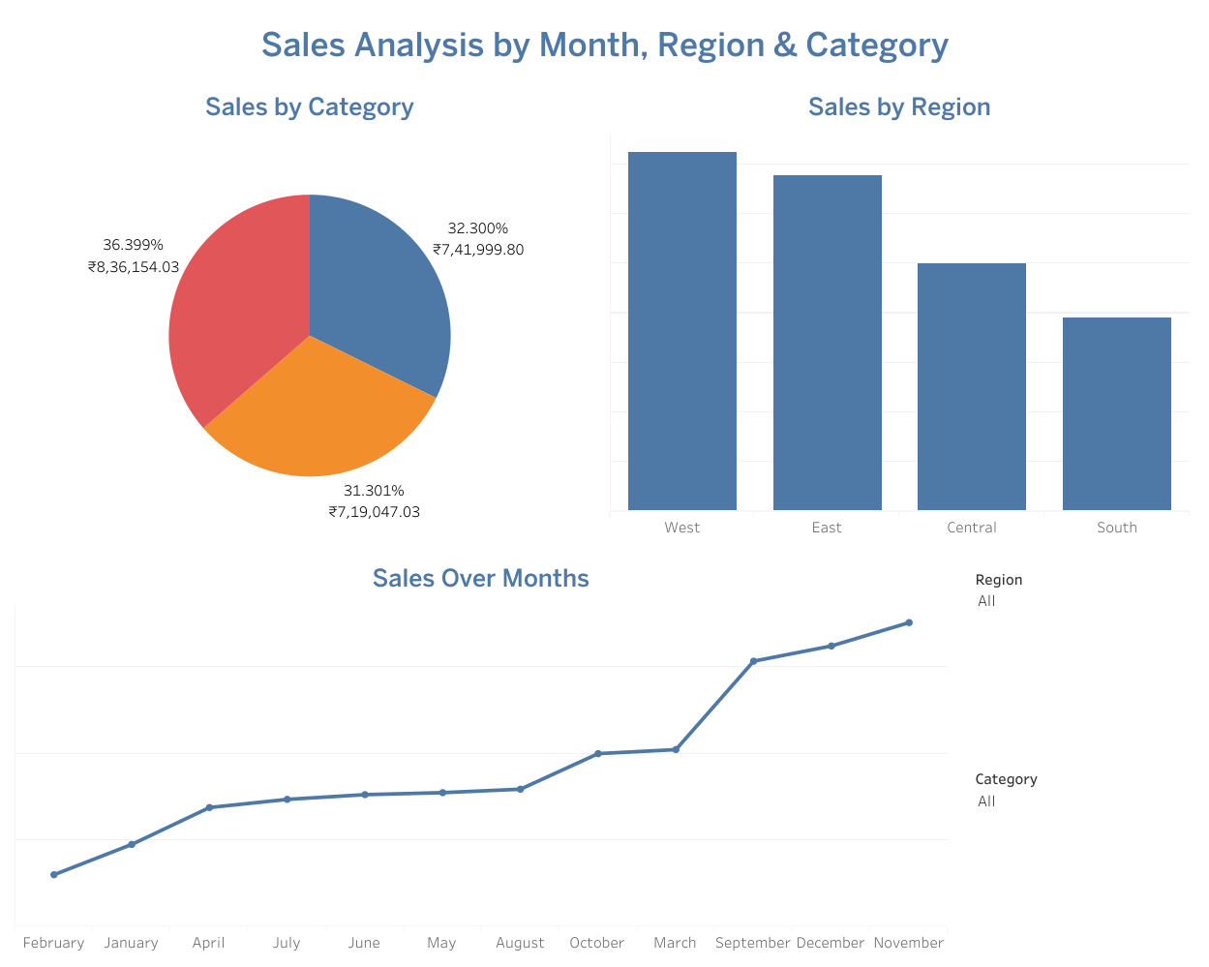

7. Key Insights
- Sales Trend: Sales show strong seasonality with peaks in Q4 months.
- Regional Performance: The West region consistently outperforms others in sales volume.
- Category Contribution: Technology contributes the largest share of sales, while Furniture has lower share but higher profit margins.

8. Outcome
- Successfully built a clean, interactive Tableau dashboard summarizing sales performance.
- Dashboard provides actionable insights for business users to monitor trends, regional contributions, and category-level performance.
- This project enhanced understanding of data visualization best practices and business storytelling with Tableau.

9. Conclusion
The Tableau dashboard successfully consolidates sales data into an interactive, easy-to-understand format. By visualizing sales across time, region, and category, business users can quickly identify trends, compare performance, and make data-driven decisions.
- Time-based analysis highlighted seasonal sales peaks.
- Regional comparison revealed that the West region leads in sales performance.
- Category analysis showed that Technology contributes the largest revenue share.
Overall, this project demonstrates how Tableau can transform raw data into actionable insights, supporting better business planning and strategy.

